* **Idea:**
* **Formal idea name: Summarizing System**
* **Commercial Name: Summarization Program**
* **Group Members:**

1. **Mariam Bayoumy**
2. **Monika Atfy**
3. **Ahmed Moustafa**
4. **Michael Ashraf**

* **Description:**

1. **Our system is working on summarizing text file according to percentages.**

* **Features:**

**1) Allowing user to insert a text file and summarization percentage.**

**2) Generating summarized files for each percentage in a descending order.**

* **Technical Description:**

1. **File IO**
2. **Exception Handling**
3. **Streams**

* **Memory:**

**-Primitives no of variables:**

* **Global => 10**
* **Local => 1**

**-Data Structures:**

* **Arrays => 4**
* **Lists => 15**

**-No of loops => 11**

* **Decision Points (number of Branches):**
* **If condition => 11**
* **Modules:**

**Methods => 2**

* **Screenshots:**
* **Page (1):**

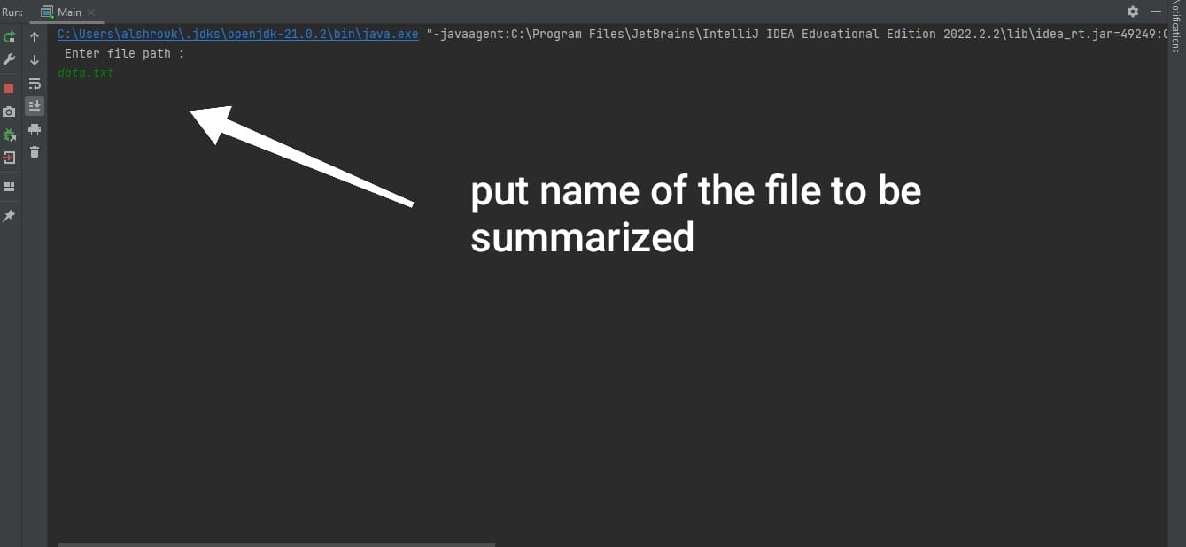

* **Page (2):**

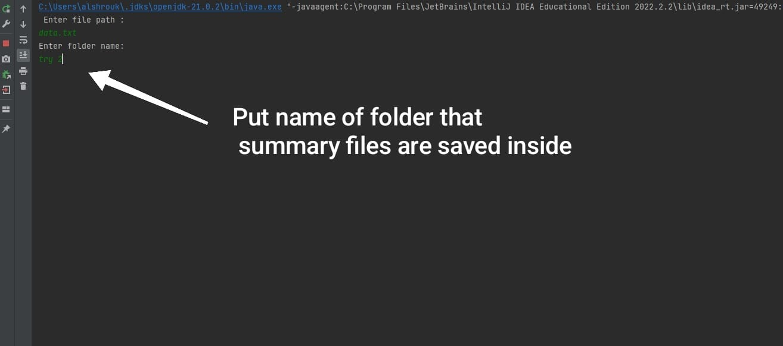

* **Page (3):**

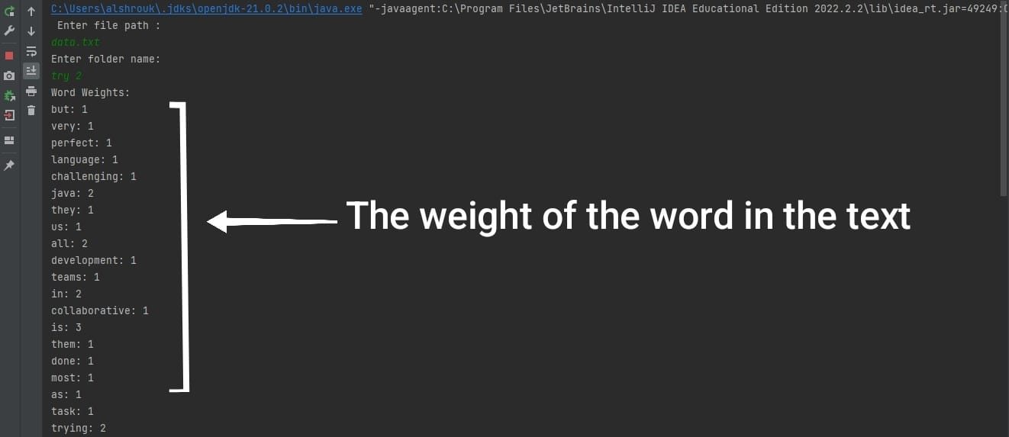

* **Page (4):**

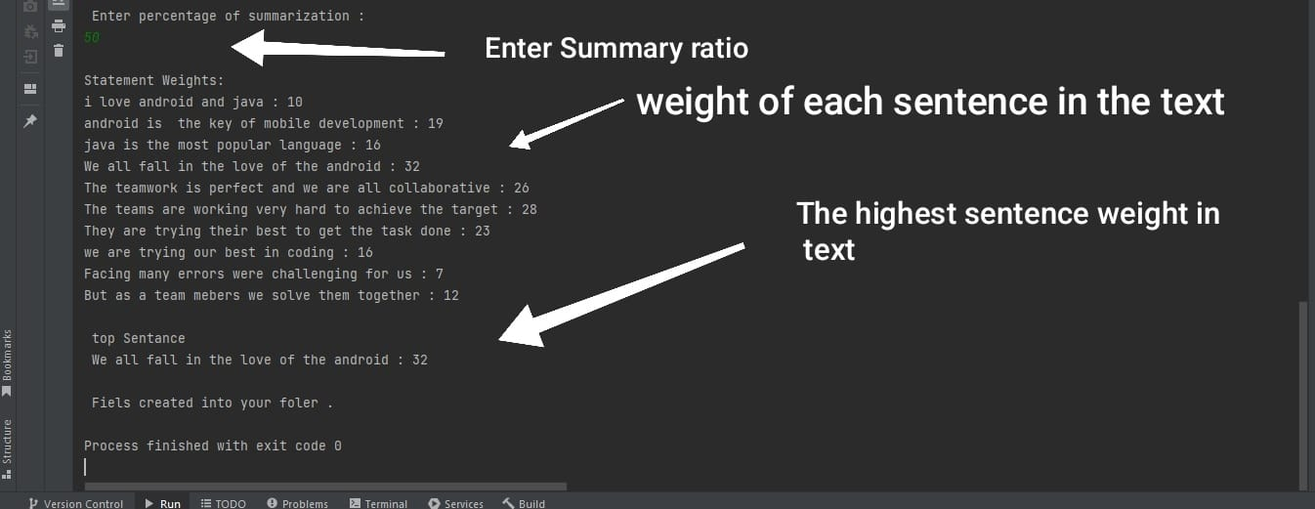

* **Page (5):**

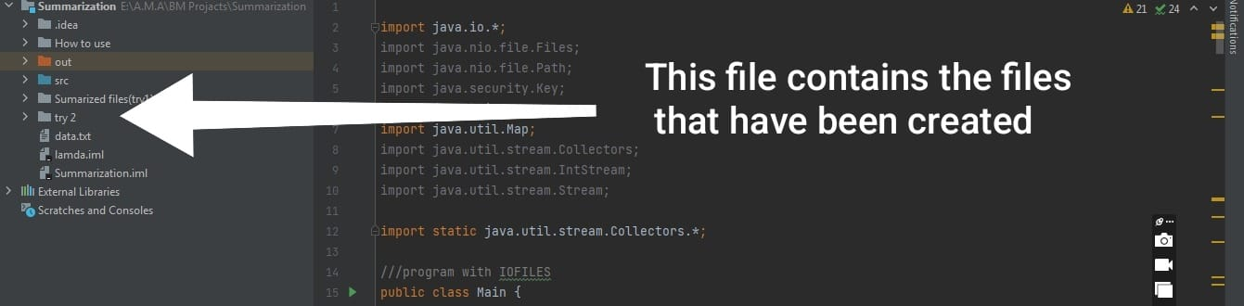

* **Use case diagram:**

